**Abdalrhman Abdalla**

Lab2

1. Is your browser running HTTP version 1.0 or 1.1?

1.1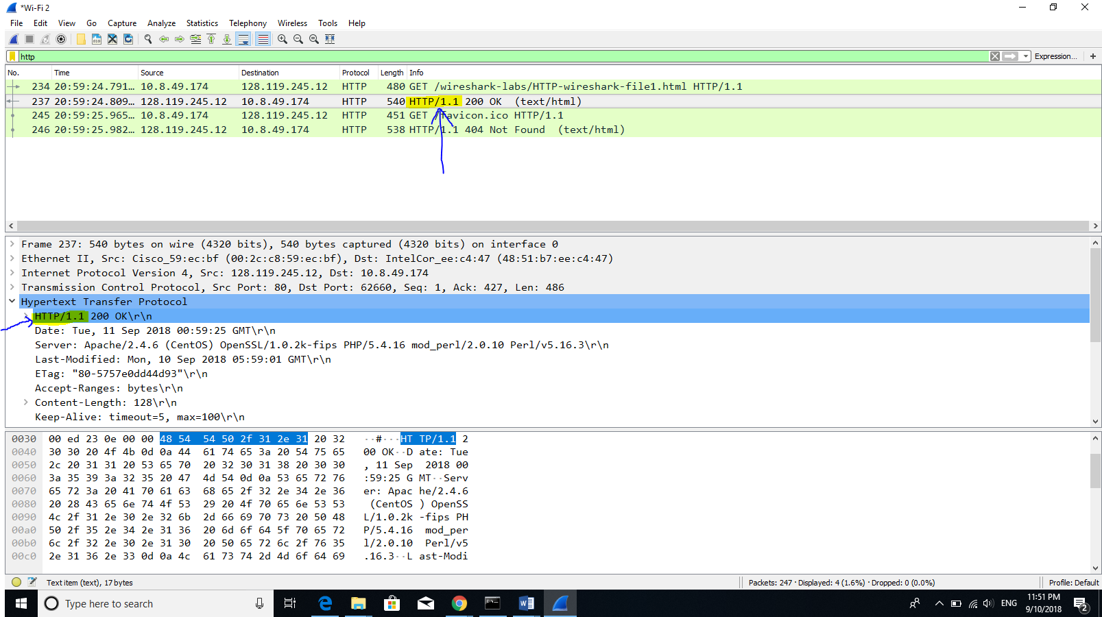

1. When was the HTML file that you are retrieving last modified at the server?

Mon 10 Sep 2018 05:59:01 GMT

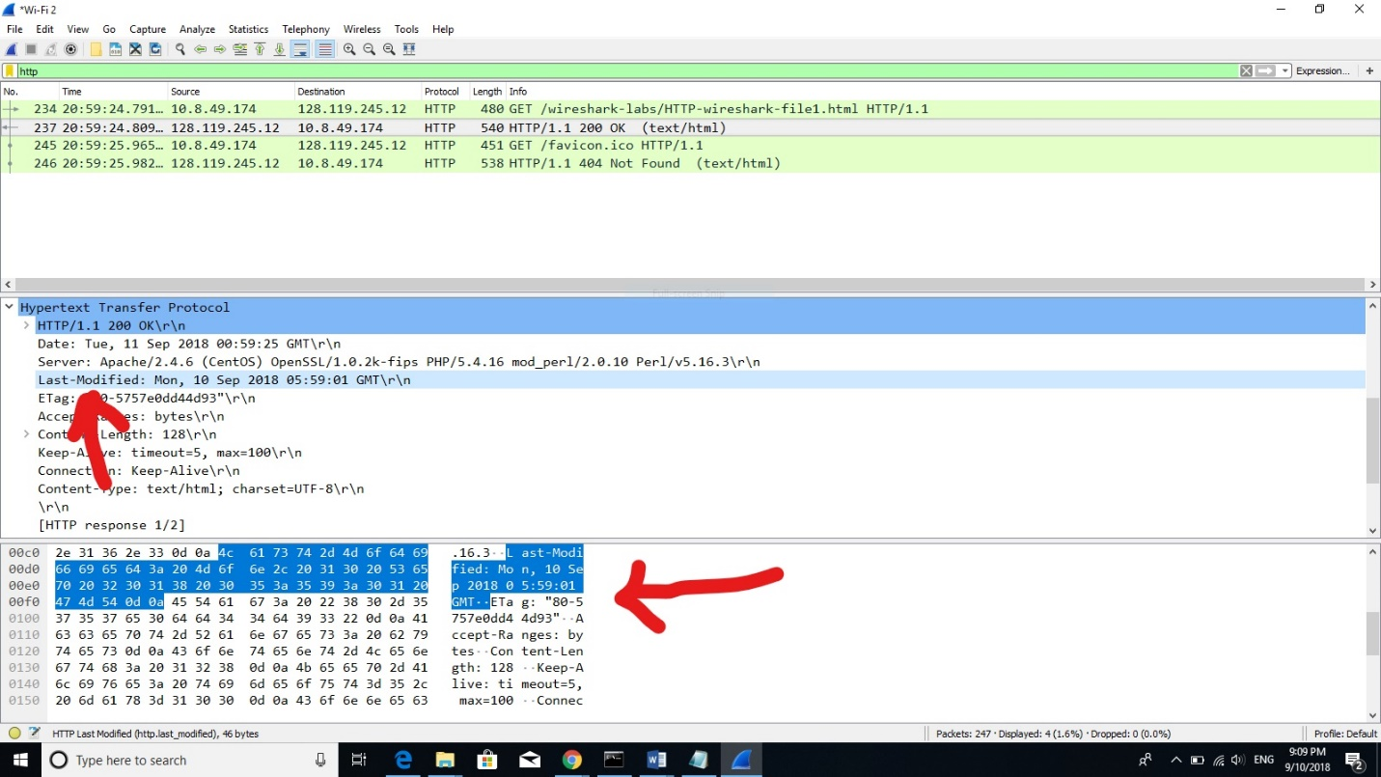

1. What is the IP address of your computer? Of the gaia.cs.umass.edu server?

My ip 10.8.49.174 Gaia ip 128.119.245.12

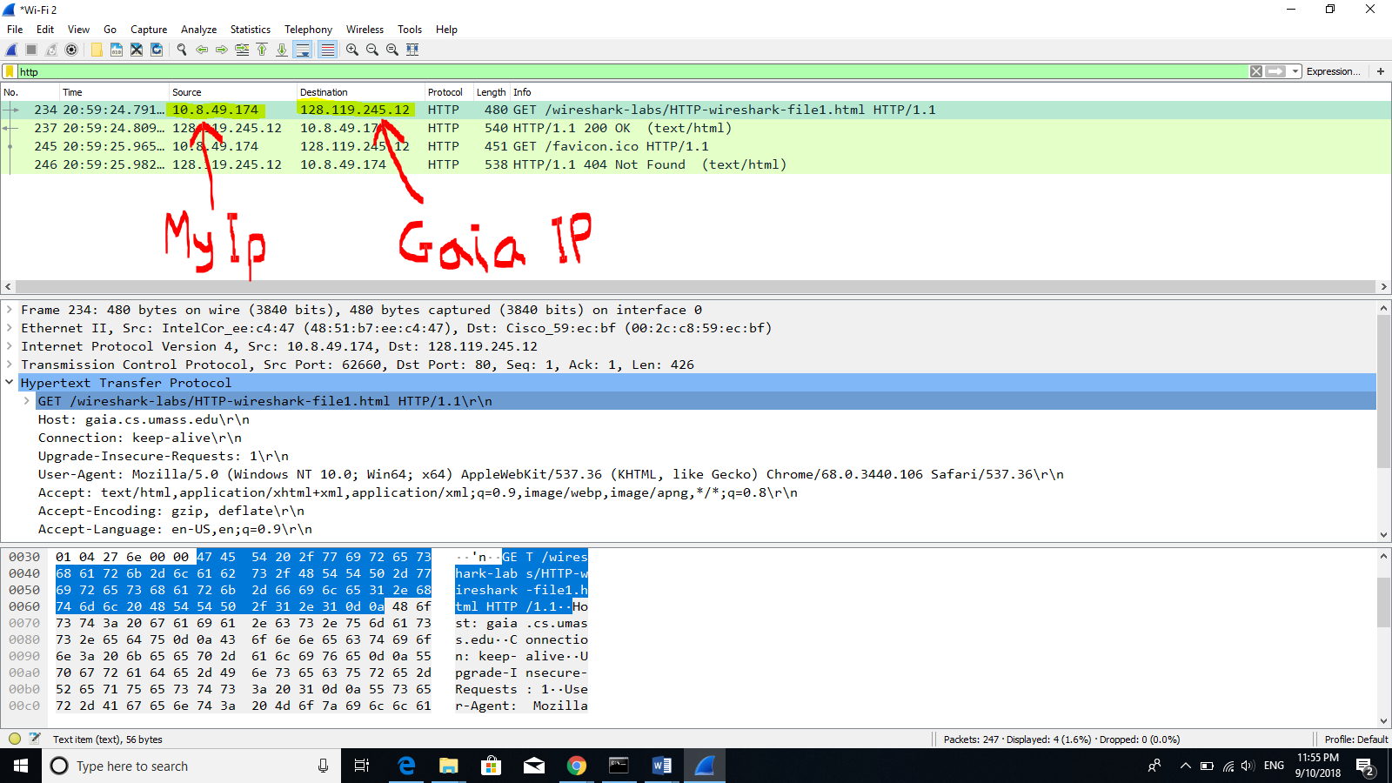

1. What languages (if any) does your browser indicate that it can accept to the server?

EN-US, EN

